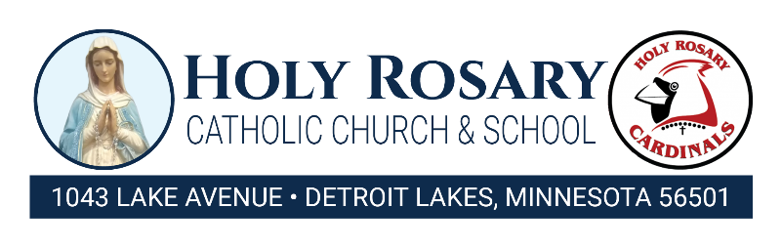
Unpaid Meal Charge and Debt Collection Procedure
Purpose
The purpose of this policy is to establish consistent district practices for the provision of meals to students who have insufficient funds in their school meal accounts and the collection of unpaid meal debt.
General Statement of Policy
1. Holy Rosary School’s goal is to provide nutritious meals to students to promote healthy eating habits and enhance learning as well as maintain the financial integrity of the National School Breakfast and Lunch program and eliminate stigmatization of children who are unable to pay meal charges.
2. It is the policy of Holy Rosary School to offer breakfast and lunch meals that meet state and federal guidelines.
3. Holy Rosary School allows for pre-payments and billed payments.
4. Families may apply for free/reduced-price meal benefits anytime during the school year. The Application for Educational Benefits is distributed to all families in the district prior to the student’s first day of classes. In addition, the Application for Educational Benefits is available in the Holy Rosary School Office during regular school hours. If household income or size changes, families can apply for meal benefits anytime during the school year.
5. Holy Rosary School will maintain the dignity of students by prohibiting lunch shaming or otherwise ostracizing the student.
Charge Policy
1. If the student or family account has insufficient funds to pay for a la carte items or second meals, Holy Rosary School will make a note on the school roster, discreetly and add it to the student’s electronic billing system.
2. Once staff have placed a meal on a tray or otherwise served the meal to a student, the meal may not be subsequently withdrawn from the student by the cashier or other school official, whether or not the student has an outstanding meals balance.
3. Students eligible for free or reduced-price meals will always be served a meal regardless of unpaid food service accounts.
4. When a student eligible for PAID meals has “cash in hand” to pay for a meal, the student will be served a meal regardless of unpaid foodservice accounts. The “cash in hand” will not be applied towards past due balances.
5. Alternate meals may not be provided to students as a result of school lunch debt. Providing an alternate meal not on the scheduled menu violates a Minnesota law (Minn. Stat. § 124D.111) that requires respectful treatment of students regarding school lunch debt.
Notification of Account Status
1. Any reminders for payment of outstanding student meal balances will not demean or stigmatize any child participating in the school lunch program, including but not limited to dumping meals, withdrawing a meal that has been served, providing an alternate meal, announcing or listing students' names publicly, or affixing stickers, stamps, or pins.
2. Families can contact the office for account balances or check their online accounts.
3. Families will be contacted via email or a letter in their student’s weekly communication envelope if their student has a negative or unpaid account balance.

Collection of Unpaid Meal Debt
When the student meal balance is -$1.00 the following collection actions will be taken:
1. Elementary: -$1.00
2. Middle School: -$1.00
The school/district will not utilize collection agency services to collect unpaid school meal debt.
- School office manager will contact the household to request payment
- The building principal will contact the family and review with them their responsibility to provide funds for their student.
- Fees owed will be added to final school year tuition bill
Non-Discrimination Statement: This explains what to do if you believe you have been treated unfairly. In accordance with federal civil rights law and U.S. Department of Agriculture (USDA) civil rights regulations and policies, this institution is prohibited from discriminating on the basis of race, color, national origin, sex (including gender identity and sexual orientation), disability, age or reprisal or retaliation for prior civil rights activity. Program information may be made available in languages other than English. Persons with disabilities who require alternative means of communication to obtain program information (e.g., Braille, large print, audiotape, American Sign Language), should contact the responsible state or local agency that administers the program or USDA’s TARGET Center at (202) 720-2600 (voice and teletypewriter [TTY]) or contact USDA through the Federal Relay Service at (800) 877-8339. To file a program discrimination complaint, a Complainant should complete a Form AD-3027, USDA Program Discrimination Complaint Form which can be obtained online at: https://www.usda.gov/sites/default/files/documents/ad-3027.pdf, from any USDA office, by calling (866) 632-9992 or by writing a letter addressed to USDA. The letter must contain the complainant’s name, address, telephone number and a written description of the alleged discriminatory action in sufficient detail to inform the Assistant Secretary for Civil Rights (ASCR) about the nature and date of an alleged civil rights violation. The completed AD-3027 form or letter must be submitted to USDA by: (1) mail: U.S. Department of Agriculture, Office of the Assistant Secretary for Civil Rights, 1400 Independence Avenue, SW, Washington, D.C. 20250-9410; or (2) fax: (833) 256-1665 or (202) 690-7442; or (3) email: program.intake@usda.gov. This institution is an equal opportunity provider.

