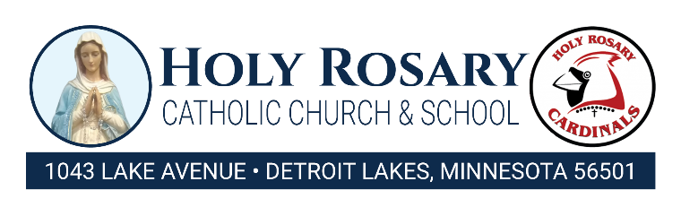
School Meals Policy Policy
Holy Rosary School participates in the Minnesota Free School Meals program as outlined in Minnesota Statutes 2024, section 124D.111, subdivision 1. In addition, this policy is to ensure that school district employees, families and students understand the expectations regarding unpaid meal charges.
Meal Service
Holy Rosary School participates in the Minnesota Free School Meals Program, and therefore all enrolled students will be offered one breakfast and one lunch at no charge while at school regardless of an outstanding meal balance. Once a meal has been placed on a student’s tray or served, it will not be taken away by the cashier or any school official, regardless of the student’s meal account status. All reimbursable meals offered meet state and federal guidelines. We will not provide an alternate meal unless related to a dietary need.
Point of service
For Holy Rosary School to receive State and Federal reimbursement for meals served, each student must be identified at the point of service. A check mark will be placed beside the name of each student taking a reimbursable meal after passing through the line. All students will be treated respectfully and in accordance with Minnesota Statute 2024, section 124D.111, subdivision 5.
Nonprogram Food Sales
To meet the non-program food revenue requirement, the nutrition program must charge and accrue revenue for items outside of the reimbursable breakfast and lunch it chooses to sell. Nonprogram Food Sales are any food or beverage sold outside of the reimbursable meal, including second meals. Self-operated and vended meal/Food Service Management Company-operated sites should manage second breakfasts and lunches at the site level. If you have students who want to purchase a second meal, adjust your ordering or preparation at that site as needed. Decisions will be made at the time of purchase depending on the food quantity available at the time of service.
Unpaid Meal Charges
Prior year unpaid meal charges
The Minnesota Free Meals Program does not address debt incurred before the program’s implementation. Holy Rosary School contacts parents by sending bills home through weekly communication envelopes, email or phone calls. Once an unpaid meal account is determined to be uncollectable, the Holy Rosary School does not use a collections agency to collect the funds.
Current year unpaid meal charges
The Minnesota Free School Meals Program pertains only to reimbursable meals. Holy Rosary School contacts parents by sending bills home through weekly communication envelopes, email or phone calls.
Communication Policy This policy and any pertinent supporting information will be provided in writing (i.e., mail, email, back-to-school packet, student handbook, etc.) to:
• All households before the start of each school year;
• Students and families who transfer into the school district, at the time of enrollment
• All school district personnel who are responsible for enforcing this policy.
Holy Rosary School will post this policy on the school district’s website, in addition to providing the required written notification described above.
Holy Rosary School will ensure that any third-party provider with whom the school district enters into either an original or modified contract after July 1, 2021, adheres to the school district’s school meals policy.
U.S. Department of Agriculture (USDA) Nondiscrimination Statement In accordance with federal civil rights law and USDA civil rights regulations and policies, this institution is prohibited from discriminating on the basis of race, color, national origin, sex (including gender identity and sexual orientation), disability, age or reprisal or retaliation for prior civil rights activity. Program information may be made available in languages other than English. Persons with disabilities who require alternative means of communication to obtain program information (e.g., Braille, large print, audiotape, American Sign Language), should contact the responsible state or local agency that administers the program or USDA’s TARGET Center at (202) 720-2600 (voice and teletypewriter [TTY]) or contact USDA through the Federal Relay Service at (800) 877-8339. To file a program discrimination complaint, a Complainant should complete a Form AD-3027, USDA Program Discrimination Complaint Form which can be obtained online at: https://www.usda.gov/sites/default/files/documents/ad-3027.pdf, from any USDA office, by calling (866) 632-9992 or by writing a letter addressed to USDA. The letter must contain the complainant’s name, address, telephone number and a written description of the alleged discriminatory action in sufficient detail to inform the Assistant Secretary for Civil Rights (ASCR) about the nature and date of an alleged civil rights violation. The completed AD-3027 form or letter must be submitted to USDA by: 1. mail: U.S. Department of Agriculture Office of the Assistant Secretary for Civil Rights 1400 Independence Avenue, SW Washington, D.C. 20250-9410; or 2. fax: (833) 256-1665 or (202) 690-7442; or 3. email: Program.Intake@usda.gov This institution is an equal opportunity provider.

