Revised: 5/2/2025
Approved 5/8/2025
Revised 2/15/2026

HOLY ROSARY SCHOOL
WELLNESS POLICY
Revised February 2026

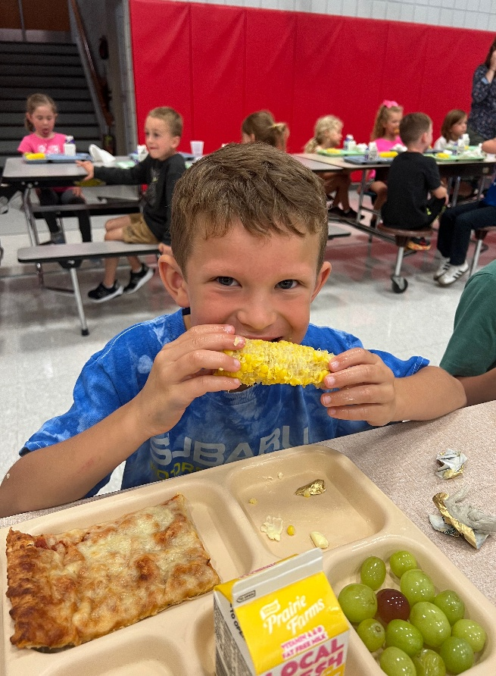

Holy Rosary School is committed to providing a healthy school and community environment that enhances student learning and the development of lifelong wellness practices. Students will develop the knowledge and skills necessary to make nutritious and enjoyable food choices. In addition, staff are encouraged to model healthy eating and the importance of physical activity. Holy Rosary School strives to implement a comprehensive wellness plan that encourages healthy eating, physical activity, and mental health while equally serving the needs and interests of all students and staff as they learn to respect their bodies as temples to do God’s work.

Holy Rosary School utilized the WellSat 3.0 wellness school assessment tool found at https://www.wellsat.org/ to develop our wellness plan based upon the standards of Nutrition Education, Standards for USDA Child Nutrition Programs and School Meals, Nutrition Standards for Competitive and Other Foods and Beverages, Physical Education and Activity, Wellness, Promotion, and Marketing, and Implementation, Evaluation, and Communication.

Education: Holy Rosary School (HRS) will provide nutrition education as a part of a standards-based, sequential curriculum, encourage and support healthy eating by students, and engage in nutrition promotion that (is):
- Offered as part of a comprehensive program designed to provide students with the knowledge and skills necessary to promote and protect their health in preschool – 8th grade.
- Part of health education classes as well as classroom instruction in subjects such as math, science, language arts, and social science, where appropriate.
- Strives toward integrating nutrition into a coordinated school health approach.
- Discusses our school wellness policy at student/parent meetings in the fall, send home copies of the policy, and post the school wellness policy on our website.
- Displays healthy eating information in the cafeteria. The school will not display or advertise unhealthy foods or soft drinks.
- Encouraged by teachers, staff, and food service personnel through participation in worksite wellness opportunities and role modeling of healthy behaviors.

- SCHOOL HEALTH COUNCIL
Holy Rosary School will strengthen and work within the existing school health council to develop, implement, monitor, review, and, as necessary, revise school nutrition and physical activity policies.

- NUTRITIONAL QUALITY OF FOOD AND BEVERAGES SOLD/SERVED ON CAMPUS

- SCHOOL MEAL PROGRAM School Meals are:
  - The main source of nutrition during the school day.
  - Nutritious, appealing, and served in a safe, clean, and enjoyable setting.
  - Served in an environment that encourages healthy eating and food habits.
  - In compliance with or exceeding the most updated safety standards and US Department of Agriculture (USDA) school lunch guidelines.
  - Offer nutrient-rich fresh fruit and/or vegetables, whole grains, and other minimally processed foods daily.
  - Incorporates local foods into school meals and promotes Farm to School activities in the cafeteria and classroom and as a component of field trips.
  - Designed to encourage students through surveys and taste-tests of new entrees and local fresh fruits and vegetables.
  - Serve only low-fat and fat-free milk. No flavored milk will be made available. Nutritionally equivalent non-dairy alternatives will be offered when requested in writing by parent/guardian, with a signed Special Diet Statement, by a licensed physician, physician assistant, or advanced practice registered nurse such as a certified nurse practitioner.
  - Ensure that at least half of the served grains are whole grains. Provide whole-grain bread products daily as recommended by the Federal Government.
  - Use serving sizes that meet minimum and don’t exceed maximum USDA requirements.
  - Strive to replace high-fat items with lower-fat items, as appropriate.
  - The daily menu, meeting USDA requirements, will be posted daily in the cafeteria and shared with students, parents and staff.
  - Monthly menus sent home detailing breakfast and lunch offerings.
  - Cafeteria supervision shall be provided, and rules for safe behavior shall be consistently enforced.
  - Students have access to handwashing before they eat meals.
  - Provides access to clean, free drinking water for students during the day.
  - Staff will discourage students from sharing their food or beverages during meal or snack times, given concerns about allergies and other restrictions on some children's diets.
  - Parents are encouraged to call ahead and eat school lunch with their child.
  - Parents/guardians are highly discouraged from bringing outside food, such as fast-food meals, into the cafeteria.
  - Cold lunches brought from home are encouraged to meet Guidelines for Nutritious lunches.

- Breakfast To ensure that all children have breakfast, either at home or at school, to meet their nutritional needs and enhance their ability to learn:
- The school will operate the School Breakfast Program.
- The school will notify parents and students of the availability of the School Breakfast Program.
- The school will encourage parents to provide a healthy breakfast for their children through newsletter articles, take-home materials, or other means.

- Afterschool Program HRS offers an after-school program that meets Minnesota State and National School Lunch Program standards and requirements, and is reimbursed through the National School Lunch Program

- Free and Reduced-priced Meals: HRS will make every effort to eliminate any social stigma attached to, and prevent the overt identification of, students who are eligible for free and reduced-price school meals. Toward this end, schools may utilize electronic identification and payment systems; provide meals at no charge to all children, regardless of income; promote the availability of school meals to all students; and/or use nontraditional methods for serving school meals, such as "grab-and-go."

- Meal Times and Scheduling
- HRS will provide students with at least 10 minutes to eat after sitting down for breakfast and 20 minutes after sitting down for lunch; and will schedule meal periods at appropriate times, e.g., lunch will be scheduled between 11 a.m. and 1 p.m.
- HRS Staff should not schedule tutoring, club, or organizational meetings or activities during mealtimes, unless students may eat during such activities.
- HRS will provide students with access to hand washing or hand sanitizing before they eat meals or snacks.

- Qualifications of School Food Service Staff: Qualified nutrition professionals will administer the school meal programs. As part of the school district's responsibility to operate a food service program, we will provide continuing professional development for all nutrition professionals in schools. Staff development programs should include appropriate certification and/or training programs for child nutrition directors, school nutrition managers, and cafeteria workers, according to their levels of responsibility.

- Middle School: In middle school, all foods and beverages sold individually outside the reimbursable school meal programs (including a potential school store, or fundraising activities) during the school day, or through programs for students after the school day, will meet the following nutrition and portion size standards, in accordance with the USDA Smart Snacks Guidelines.

Snacks Holy Rosary School utilizes and promotes the USDA Guide to Smart Snack guide for all food and beverages served to students during the school day.

- Beverages
    - Allowed: plain water or seltzer water without added flavoring or caloric sweeteners; 100% fruit and vegetable juices; unflavored or flavored low-fat or fat-free fluid milk and milk alternatives as permitted by the National School Breakfast/Lunch Programs.
    - Not allowed: Any drink not in the above “allowed” category, including (but not limited to) soft drinks; sports drinks; iced teas; fruit-based drinks that contain less than 100% real fruit juice or that contain additional caloric sweeteners; beverages containing caffeine.

- Fundraising Activities. To support children's health and school nutrition-education efforts, school fundraising activities will not involve food or will use only foods (popcorn) that meet the above nutrition and portion-size standards for foods and beverages sold individually. HRS supports fundraising activities that promote physical activity through its annual Bike-a-thon and Golf Scramble.

- Snacks. Snacks served during the school day or in after-school care or enrichment programs will make a positive contribution to children's diets and health, with an emphasis on serving fruits and vegetables as the primary snacks and water as the primary beverage. HRS will assess if and when to offer snacks based on the timing of school meals, children's nutritional needs, children's ages, and other considerations. Holy Rosary School utilizes and promotes the USDA Guide to Smart Snacks guide for all food and beverages served to students during the school day.

- Rewards. HRS will not use food or beverages, especially those that do not meet the nutritional standards for foods and beverages sold individually (above), as rewards for academic performance or good behavior, and will not withhold food or beverages (including food served through school meals) as a punishment.

- Celebrations. HRS will encourage snacks at celebrations/parties that feature healthy choices.

- Composting and School Garden: The school will use its composting program and school garden as learning tools supporting the school lunch program.

- NUTRITION AND PHYSICAL ACTIVITY PROMOTION AND FOOD MARKETING

Competitive Foods: Food and beverages sold/served during the school day outside of reimbursable school meals are known as Competitive Foods. Competitive Food Nutrition Standards are developed considering the standard that school meals are intended to be the main source of nutrition for students during the school day. Holy Rosary School currently does not allow for competitive foods. However, if it did, it is the intent of HRS to protect and promote student’s health by permitting advertising and marketing for only those foods (USDA Smart Snack compliant) and beverages that are permitted to be sold on the school campus, consistent with HRS’ wellness policy.

Therefore, any other food or beverages consumed supplement that meal and must be:
- A contribution to, rather than a detraction, from the nutrition of the student
- Age-appropriate in serving size and within USDA caloric guidelines.
- Infrequent consumption
- Any foods and beverages marketed or promoted to students on the school campus* during the school day* will meet or exceed the USDA Smart Snacks in School nutrition standards.

- Holy Rosary School and parish prohibit vending machines on the campus.
- Holy Rosary School will only provide/sell the following ala carte items:
- Reimbursable meal
- 8 oz low-fat/non-fat milk
- 100% juice (35% of total calories from fat and sugars, and no trans fats)
- HRS staff will not reward students with candy but will instead offer Smart Snacks or an array of non-food choices as incentives/rewards for academic performance or good behavior.
- Milk served or sold during the school day will be limited to low-fat/non-fat milk.
- Juice sold or served to students outside the school meals will be limited to 8 oz. or less.
- The consumption of water will be encouraged throughout the day with water fountains on each school floor.

- PHYSICAL ACTIVITY OPPORTUNITIES AND PHYSICAL EDUCATION
Physical education will be standards-based, using national or state-developed standards, such as the National Association for Sport and Physical Education (NASPE) guidelines. We will follow the state law requiring instruction in Physical Education. The primary goals for Holy Rosary School’s physical activity components are:
- To provide opportunities for every student to develop the knowledge and skills for specific physical activities.
- To maintain physical fitness in a safe, adequate environment.
- To ensure students’ regular participation in physical activity.
- To teach students the short and long-term benefits of a physically active and healthy lifestyle.
- To enhance academic performance.

Accordingly, the following guidelines for physical education and physical activity at Holy Rosary School are established:
- All students will receive daily physical education (or the equivalent of 150 minutes per week for students in grades PK-5th and 225 minutes in grades 6-8)
- Students will spend at least 50% of physical education class time participating in moderate to vigorous physical activity.
- The physical education curriculum is written for every grade. It is sequential and provides an opportunity for students to learn and practice. Students will be assessed on content, developmentally appropriate motor skills, social skills, responsible behavior, physical fitness, and the benefits of physical activity.
- Holy Rosary School will provide adequate gym space and equipment for all classes. Class size is limited to ensure adequate supervision and all safety standards will be adhered to, minimizing the risk of injuries.
- Holy Rosary School will not use physical activity as punishment nor withhold physical education as punishment.
- Daily recess: All Holy Rosary students will have at least a 20-minute supervised recess break daily, preferably outdoors (weather permitting).
- Integrating Physical Activity into the Classroom: to receive the recommended amount of at least 60 minutes of physical activity per day, and for students to fully embrace physical activity as a personal behavior, other school opportunities are:
- Classroom health education will reinforce the knowledge and self-management skills needed to maintain a physically active lifestyle and reduce sedentary activities such as watching TV and video games.
- Opportunities for physical activity may be incorporated into other subject lessons, where appropriate.
- Classroom teachers will provide short physical activity breaks between lessons, classes and/or MAP testing.
- After-school childcare will provide and encourage – verbally and through the provision of space, equipment, and activities – daily periods of moderate to vigorous physical activity for all participants.
- Holy Rosary School strives to offer physical activity programs after school in conjunction with the Public Schools, Community Education, and the Boys and Girls Club.
- Safe bicycling and walking to and from school are promoted and encouraged. A bike rack is on campus.
- Holy Rosary’s Parish encourages physical activity through the annual school marathon/bike-a-thon and basketball free-throw contest.
- Holy Rosary School encourages physical activity through its annual Staff versus Students sports-based event.
- The school will continue to provide information about physical education and other school-based physical activity opportunities before, during, and after the school day; and support parents' efforts to provide their children with opportunities to be physically active outside of school. This includes sharing information about physical activity and physical education through HRS’ website, newsletter, other take-home materials, and special events.

Staff Wellness and Health Promotion
The Wellness Committee will have a staff representative (currently the School Office Manager) who identifies and disseminates wellness resources and performs other functions that support staff wellness. Strategies are implemented to support staff in actively promoting and modeling healthy eating and physical activity behaviors. When feasible, Holy Rosary School will offer annual professional learning opportunities and resources for staff to increase knowledge and skills about promoting healthy behaviors in the classroom and school. Snacks provided for staff will be healthy.

- MONITORING AND IMPLEMENTATION

  - Holy Rosary School engages students, parents, staff, PE and other teachers, food staff, School Advisory Council, administrators, and the public in developing, implementing, annual monitoring, periodic review, and revising the Wellness Policy through its wellness committee that meets regularly.
  - After annual approval by the Holy Rosary School Advisory Council, the wellness policy will be implemented throughout the school through appropriate, available communication tools.
  - The principal shall execute administrative procedures that ensure the implementation of and compliance with the wellness policy. Holy Rosary School will develop and implement a communication plan that includes training to ensure understanding of the rationale for the wellness policy and its implementation plan.
  - Holy Rosary School food service manager will ensure compliance with the school’s food and nutrition program and report to the principal.

Triennial Progress Assessments
At least once every three years, Holy Rosary School will evaluate compliance with the wellness policy to assess the implementation of the policy and include:
- The extent to which Holy Rosary School is in compliance with the wellness policy.
- The extent to which Holy Rosary School’s wellness policy compares to the Alliance for a Healthier Generation’s model wellness policy.
- A description of the progress made in attaining the goals of Holy Rosary School’s wellness policy.
- Holy Rosary will notify households/families of the availability of the triennial progress report.

